John Hancock - Coeus Security Updates and KPI Scorecard Frontend Integration 1 Assembly v1.0
Verification Guide

Revision History
Author | Revision Number | Date
TCSCODER | 1.0 | 1/21/2017

Verification
Preconditions:
* Follow Deployment Guide.md to deploy and configure the app.
* Insert test data using Src\Server\database\RealData.sql script.

Open app in browser: http://localhost:8021/
You should see login screen. Log in using CoeusAdminUser/password credentials.

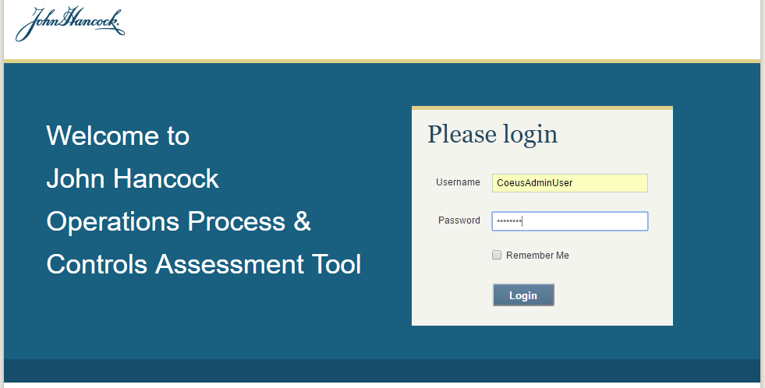
Once logged in you should see home page for PCA App:
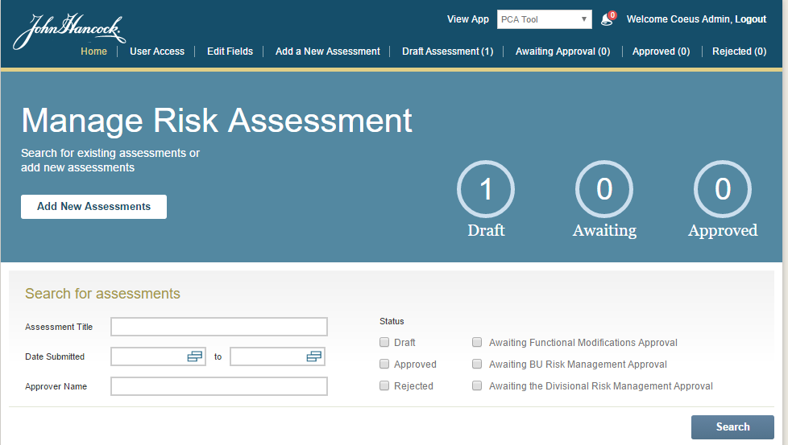

Navigate to User Access to activate KSTNormalUser user and assign to KPI tool role.
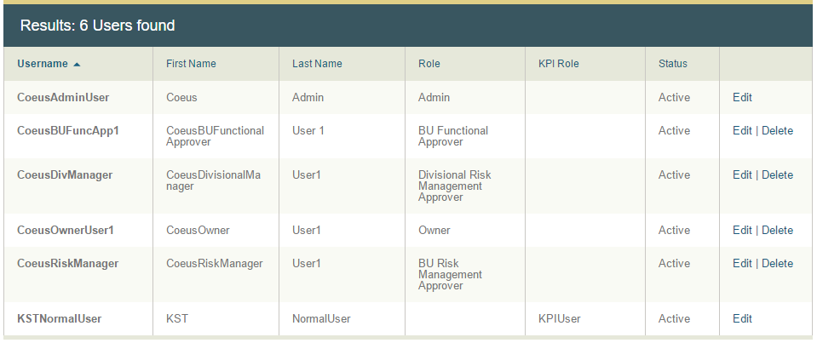

Switch the app to KPI Scorecard Tool in the dropdown selector on the top. You should see Key Performance Indicators page:

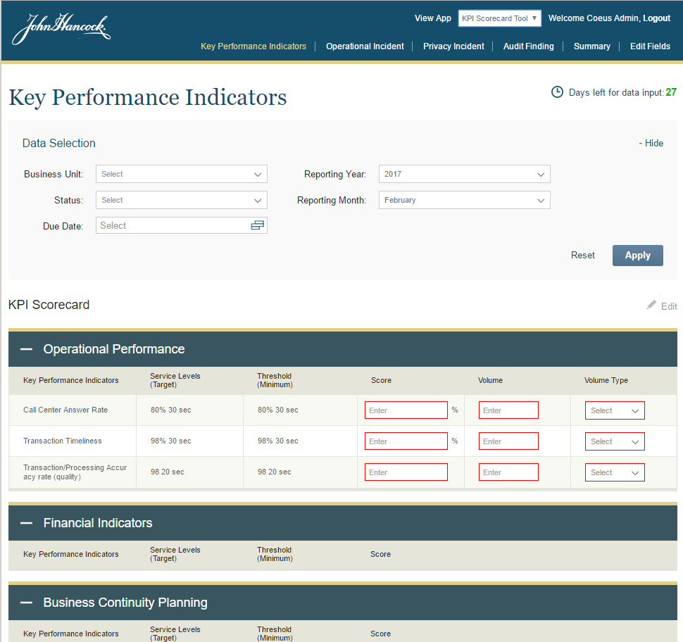

Click either on “Edit” button or Edit Fields menu. You should be redirected to Edit Fields page. (note that when redirecting using “Edit” button, the page should be scrolled to business unit section):
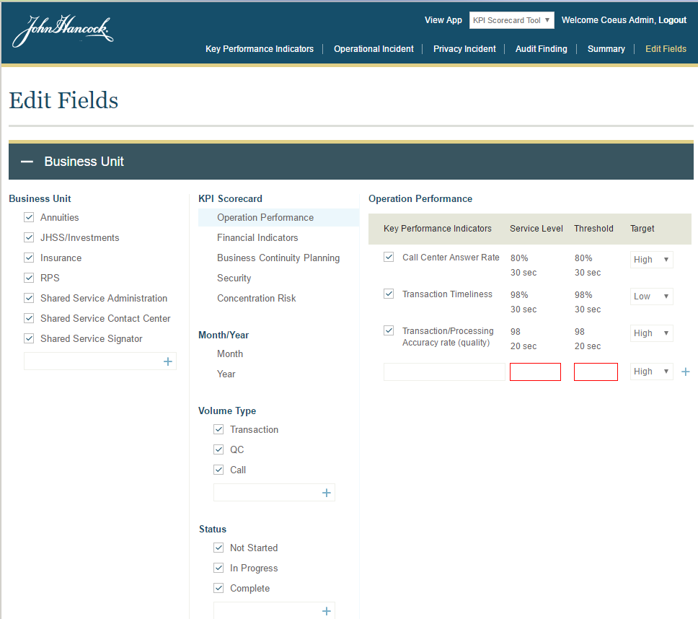

Now you can add/remove or modify the fields, similarly to PCA tool.

Now log in with KSTNormalUser/password credentials:

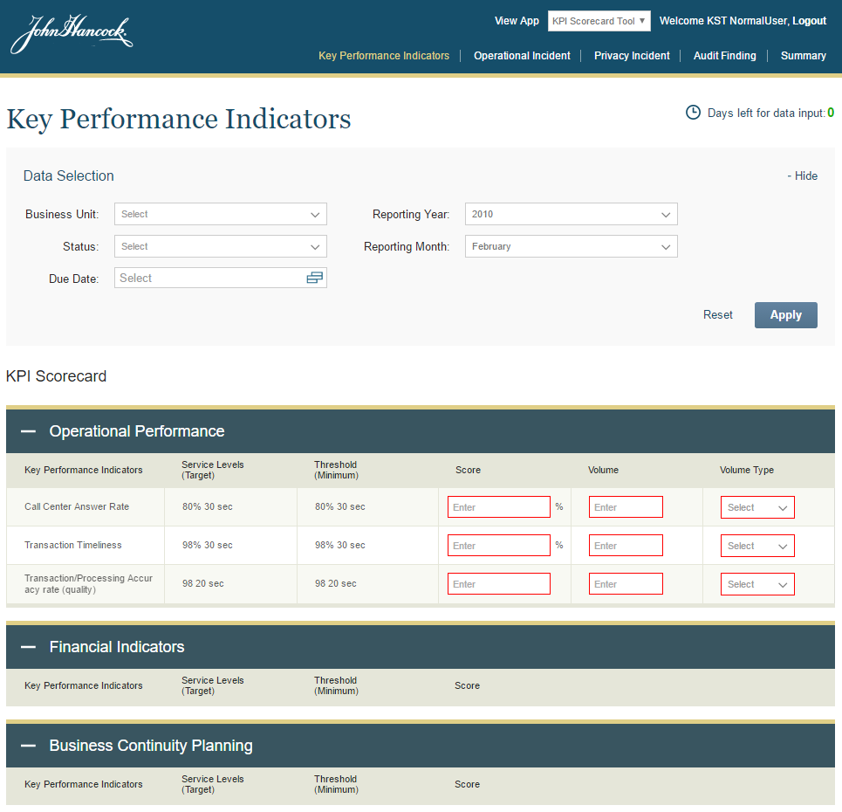

Fill all details and click Submit:
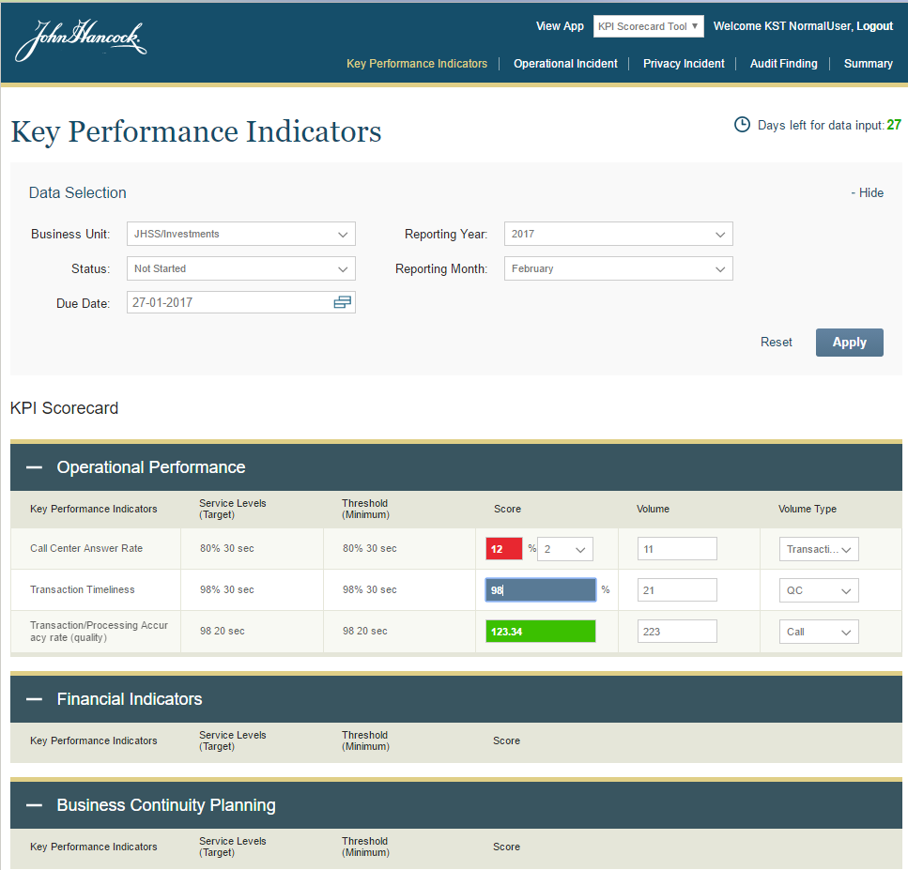
Once submitted, you should get confirmation message:
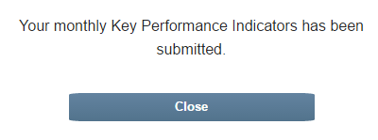

Note that data should become read-only because only admins can modify Scorecards which are not in Draft state, and also when “Days left for data input” is greater than 0.

Now reload the page and you should see that previously selected year and month are restored – they were saved as user preferences:
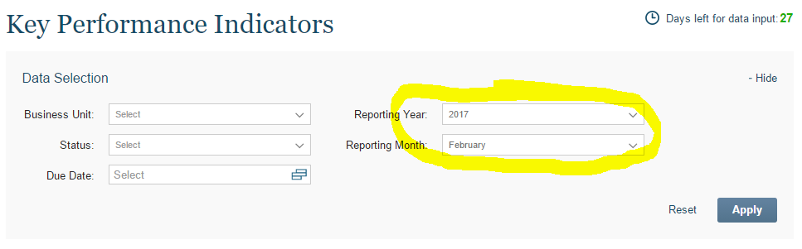

Select Business Unit that you used to create previous record and click Apply. The previously created Scorecard should be loaded in read-only mode:
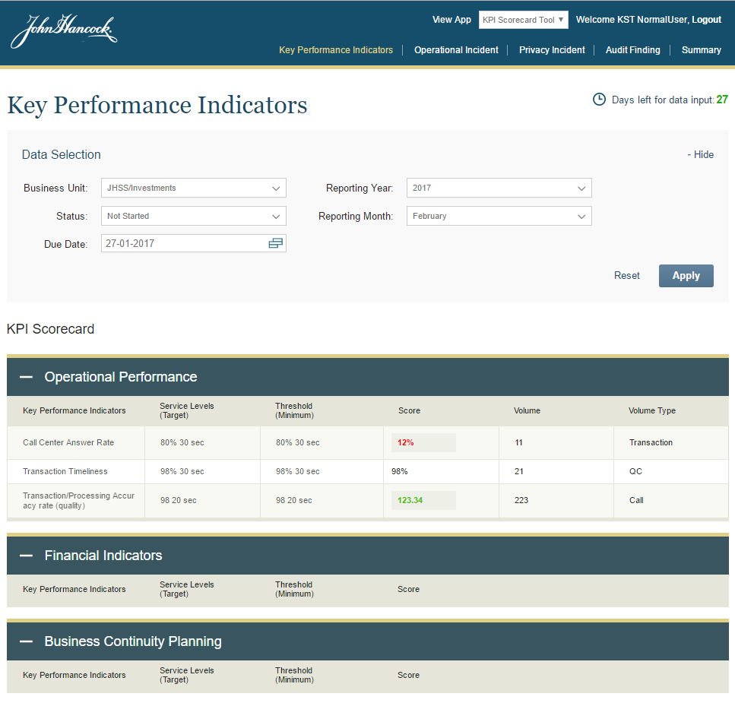

Now login with Admin user, and search for the same scorecard. It should be loaded in editable mode:
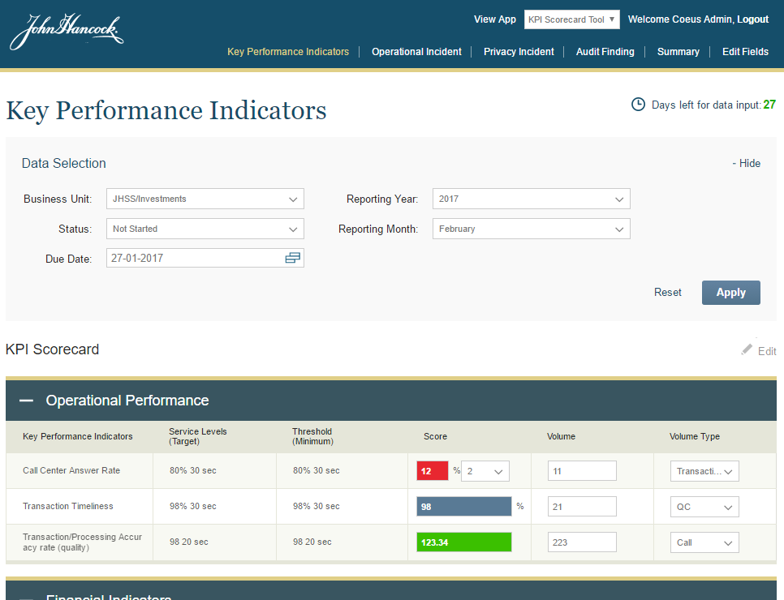

You can now update values and submit it.
Note: To verify “Days left for data inout”, you can either modify data in DB, or change your PC time to make it be 0. In this case Scorecard data should be read-only as well.

